Week 5
Creating Microservices for account and loan:
Account Microservice:
D:\1234567\microservices\account
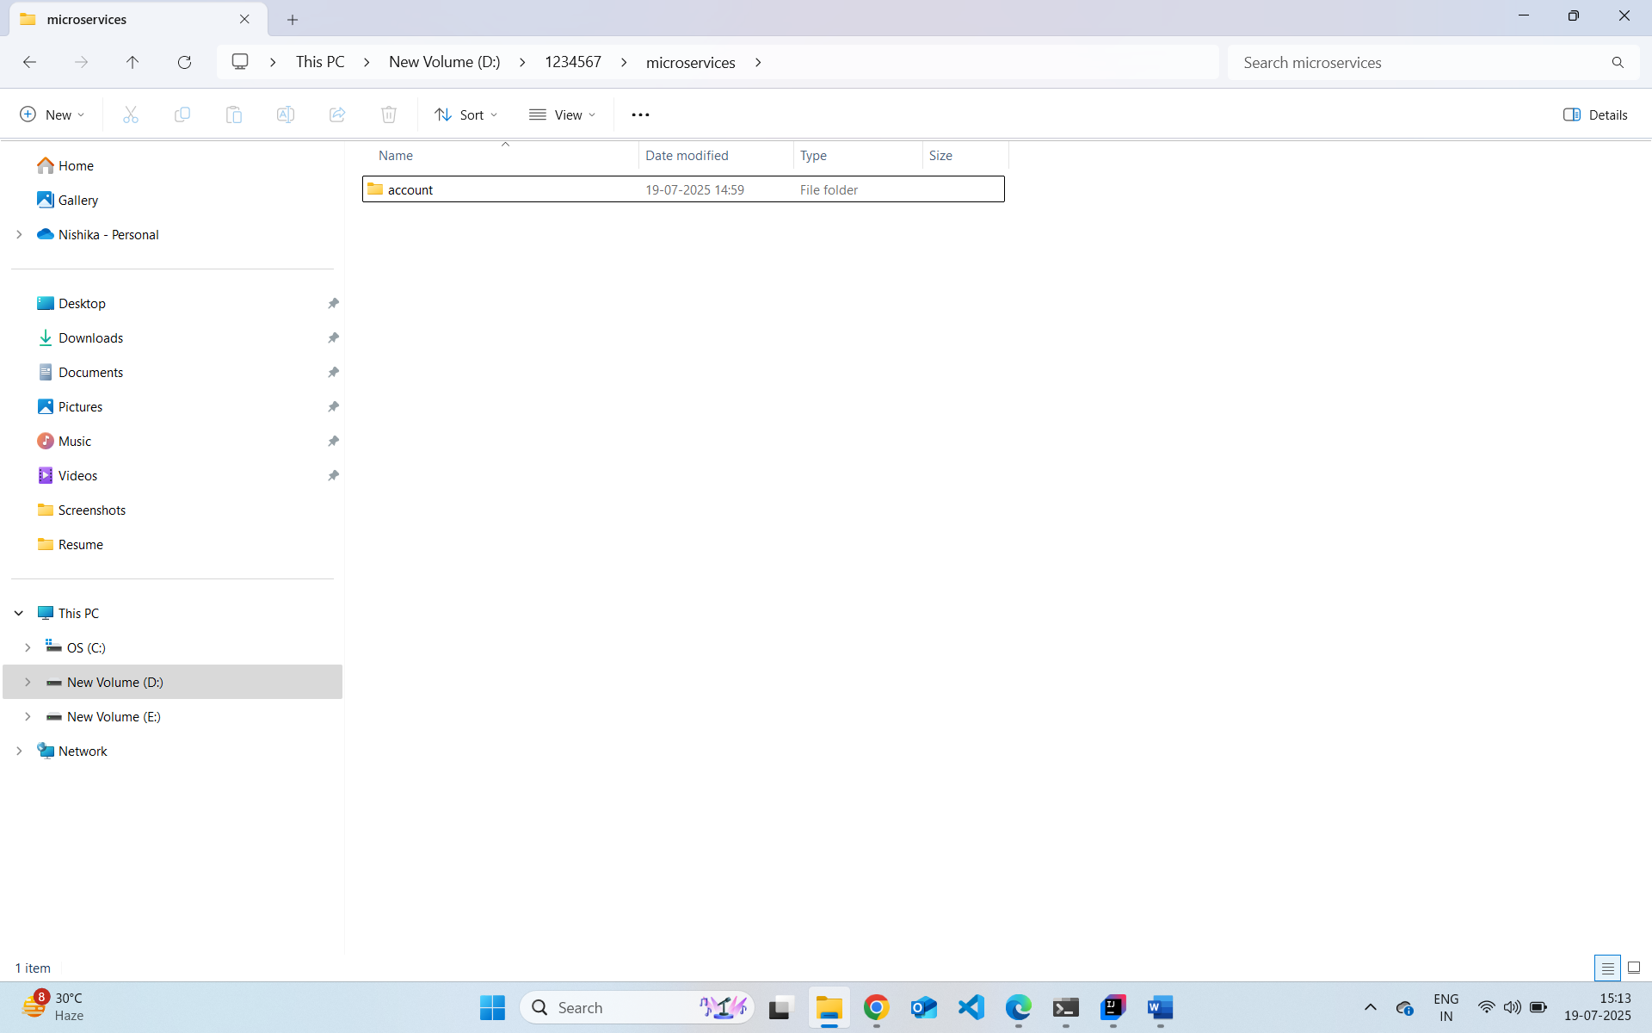
src/main/java/com/cognizant/account/controller/AccountController.java
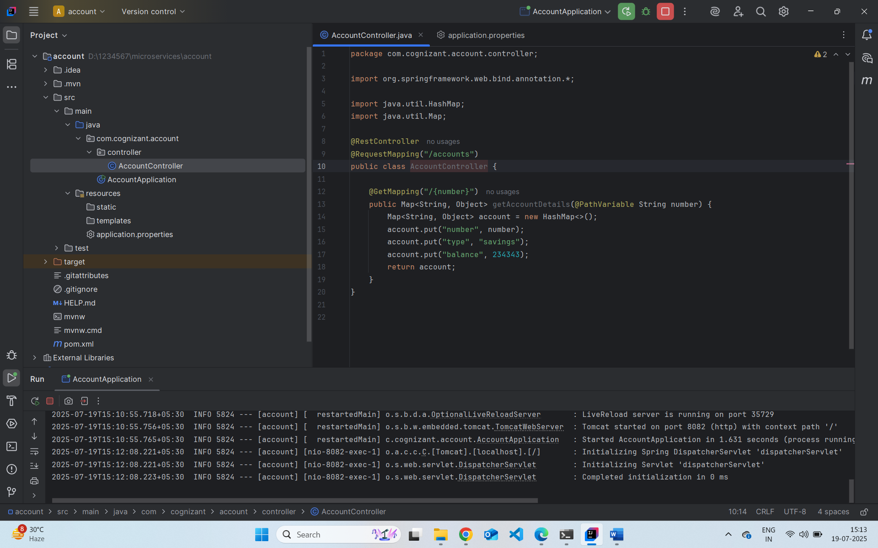
http://localhost:8082/accounts/00987987973432
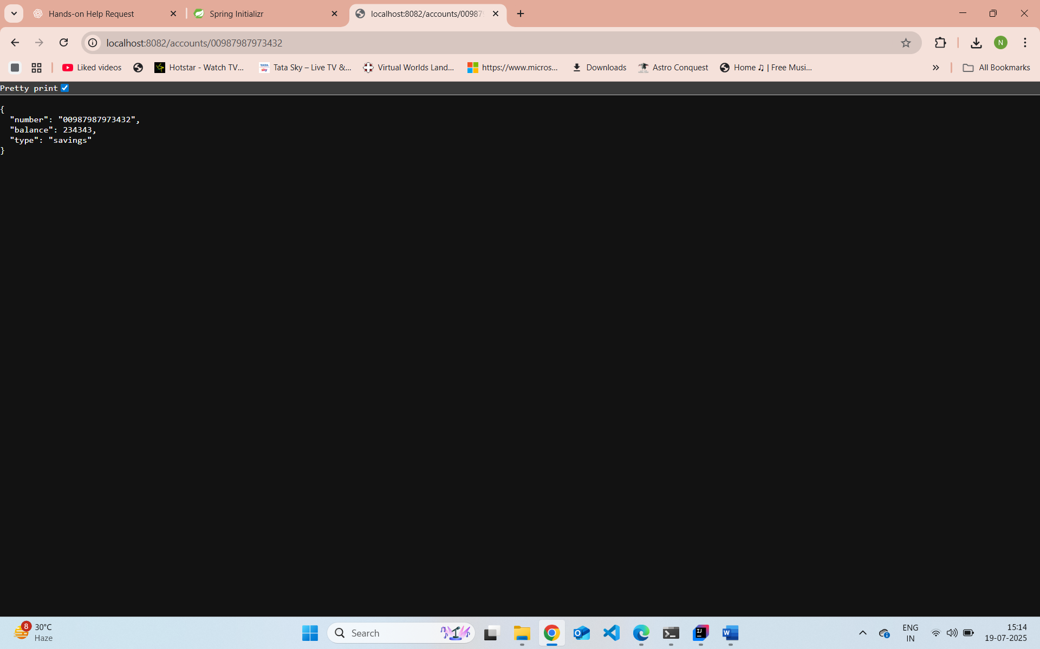

Loan Microservice
D:\1234567\microservices\loan
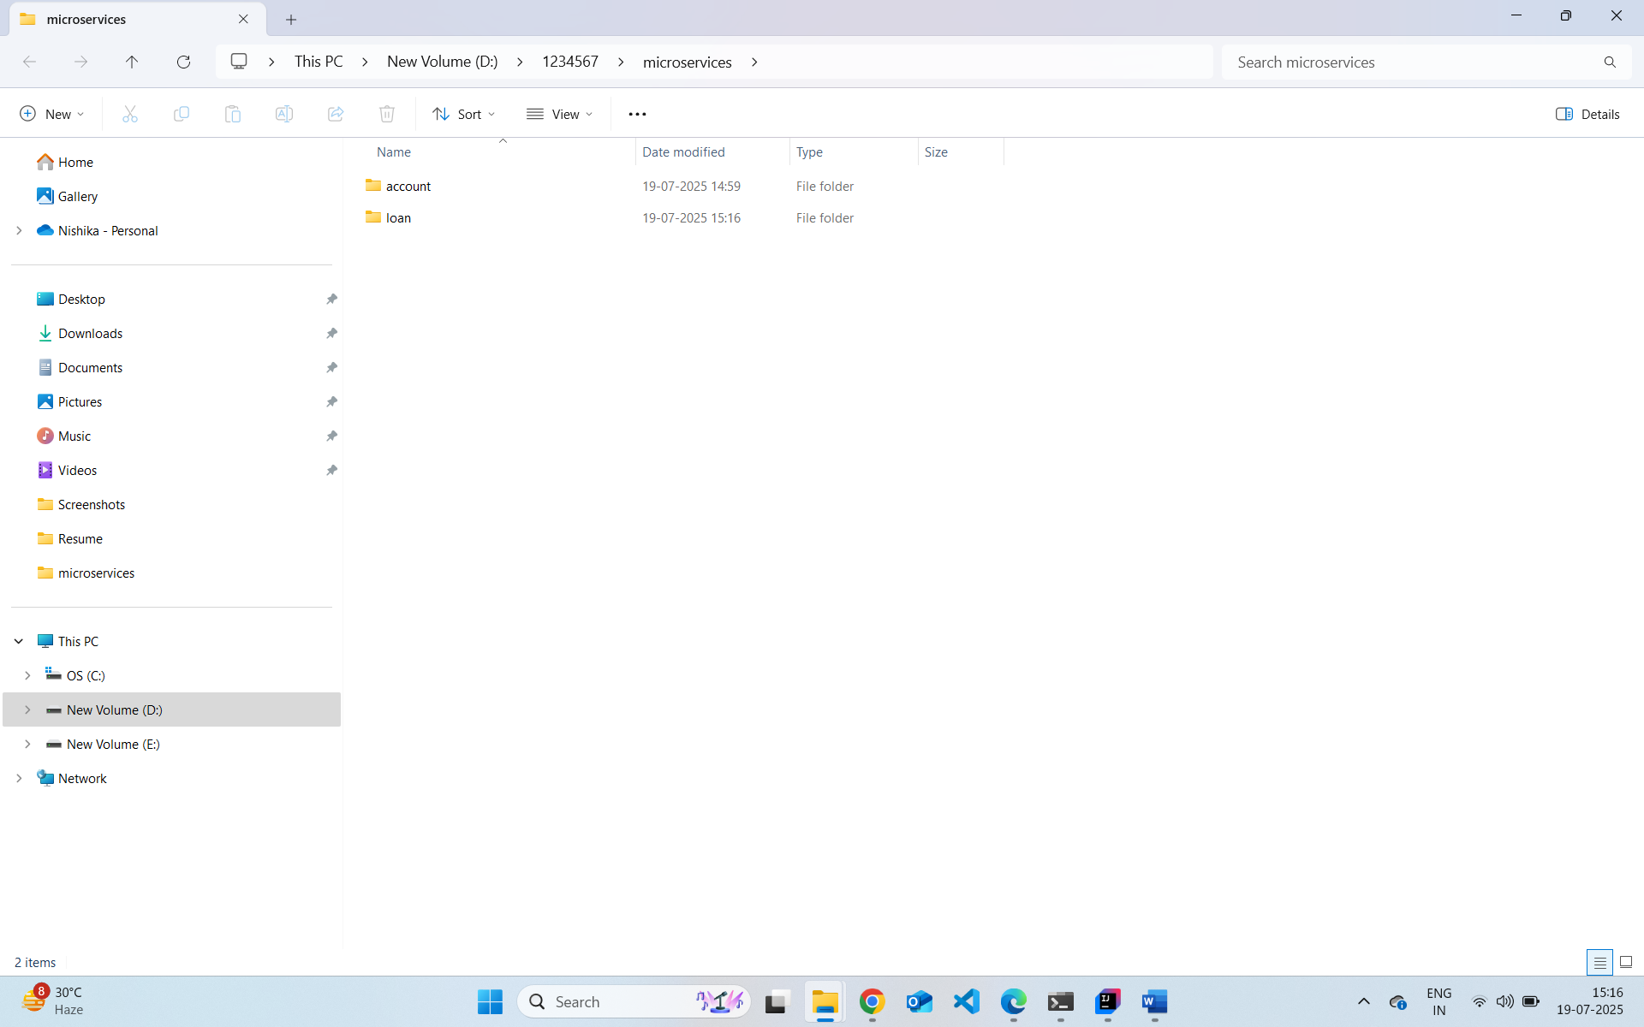
mvn clean package
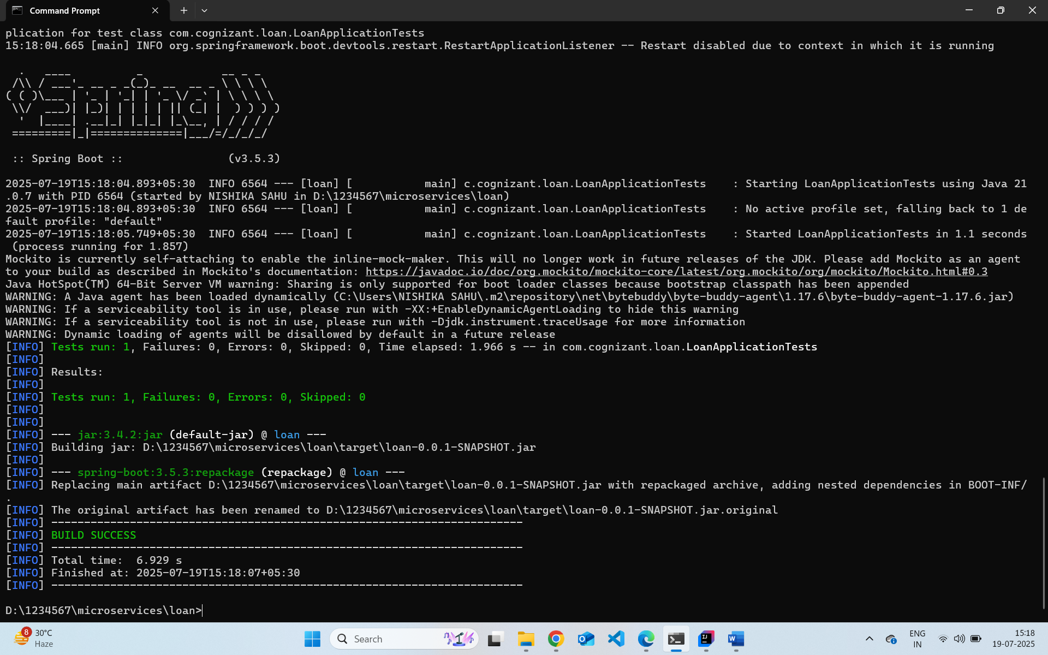
src/main/java/com/cognizant/loan/controller/LoanController.java
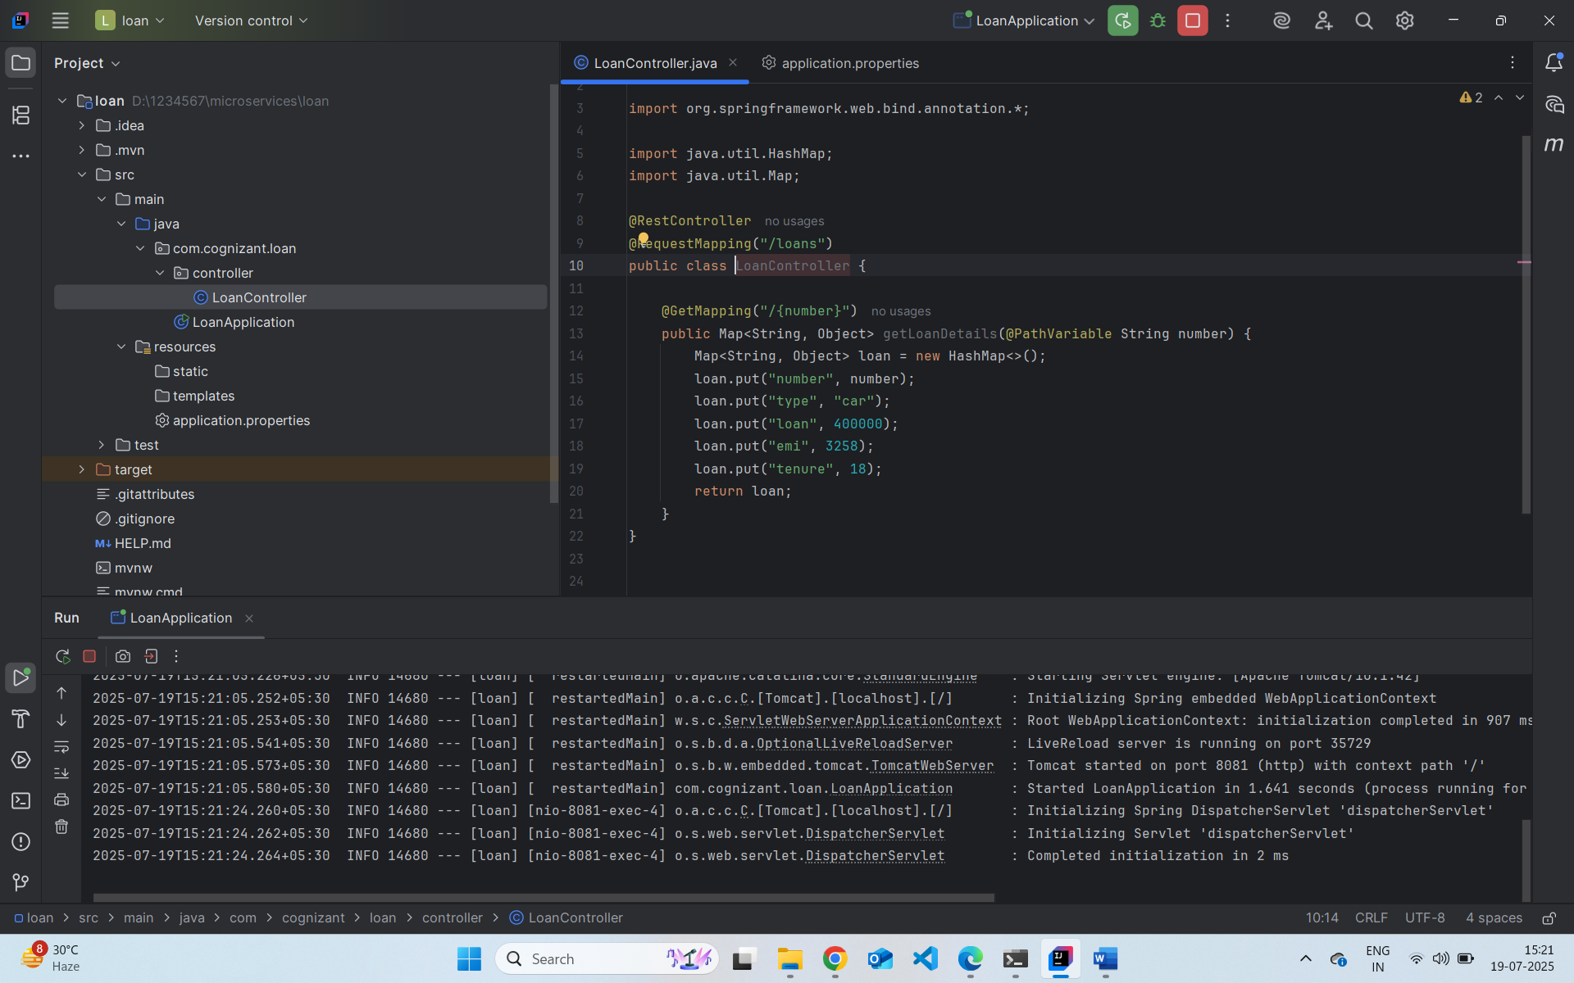
http://localhost:8081/loans/H00987987972342
